Software Project Management Plan

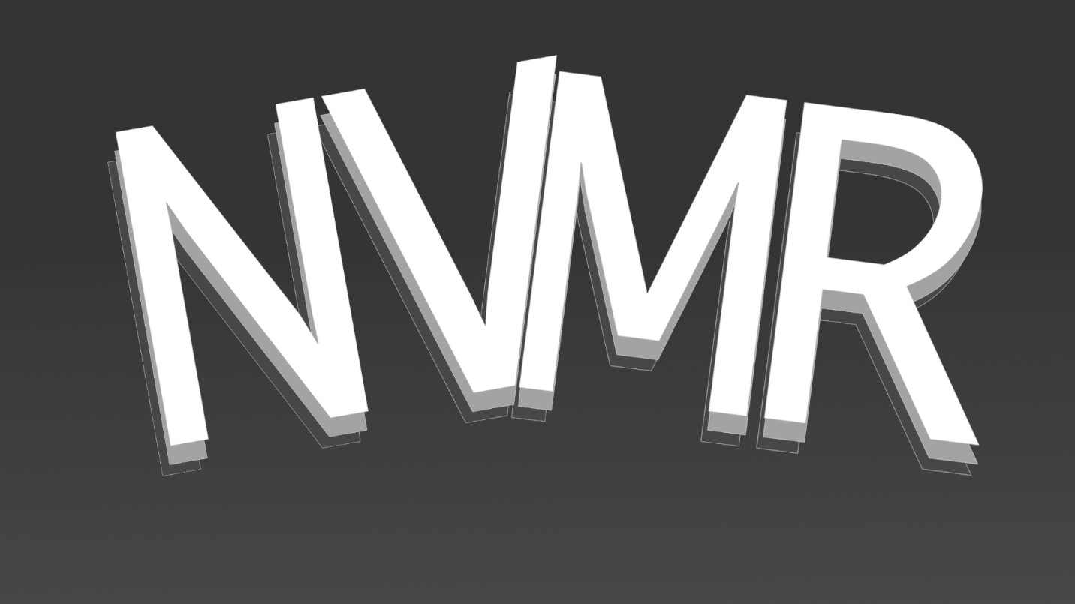**Nevermore**

Project Manager: Paul Gibbs

Team Members: Ulises Santana

Christian Strickland

Emanuel Carbajal

Daniel A. Mendez

Hussain Alabdrabalnabi

Jose Duarte

**Software Project Management Plan**

1. Overview..........................................................................................................................3

1.1 Project Summary...........................................................................................................3

1.1.1 Scope, Purpose, and Objective.........................................................................3

1.1.2 Assumptions and Constraints............................................................................3

1.1.3 Project Deliverables..........................................................................................3

1.1.4 Schedule Summary...........................................................................................4

1.2 Evolution of the Plan....................................................................................................4

1. References........................................................................................................................4
2. Definitions and acronyms................................................................................................4
3. Project organization.........................................................................................................5

4.1 External Interfaces........................................................................................................5

4.2 Organizational Tools.....................................................................................................6

1. Managerial Process Plans................................................................................................6
   1. Start-up Plan................................................................................................................6
      1. Estimation Plan
      2. Staffing Plan
      3. Resource acquisition Plan
      4. Project Staff Training Plan
   2. Work Plan....................................................................................................................6
      1. Work activities
      2. Schedule Allocation
      3. Resource Allocation
      4. Budget Allocation
   3. Control Plan..................................................................................................................7
      1. Requirements Control Plan
      2. Schedule Control Plan
      3. Budget Control Plan
      4. Quality Control Plan
      5. Reporting Plan
      6. Metrics Collection Plan
   4. Risk Management Plan.................................................................................................8
   5. Close-out Plan...............................................................................................................................8
2. Technical Process Plans ..................................................................................................9
   1. Process model
   2. Methods, Tools and Techniques
   3. Infrastructure Plan
   4. Product Acceptance Plan
3. Supporting Process Plans............................................................................................9,10
4. Additional Plans..........................................................................................................9,10
5. **Overview**

**1.1 Project Summary**

The Nevermore Project is comprised of the efforts and opinions of our group members and this document shows the best of our planning in doing so. Included in this document shows planning of our limited time and how we will work remotely due to Covid-19.

**1.1.1 Scope, Purpose, and Objective**

As other social platforms do, our project is expected to have multiple users and does not aim to have a specific audience. The planning of our project will include a web application that is also optimized for a mobile browser. For feedback, we expect to have sample clients and from our CEO and instructor Bilal Khan. We aim to improve certain aspects of social media including snapchat and twitter. The purpose is not to recreate twitter but no have a new way of interacting without having outdated personal information have negative impact on the user. One of our objectives will be to incorporate ways to have user expressions spread quickly and effectively. We also have the purpose in mind that new features implemented will not only a personal user but business accounts as well.

**1.1.2 Assumptions and Constraint**

We assume all members will contribute during meetings with the unpredictable constraint of online meetings only. Members in our group will not be working on the same machine and may include different operating systems (e.g., Linux, macOS, and Windows). Also, about half of the members in this project either don’t use twitter or are new to it.

**1.1.3 Project Deliverables**

Software Project Management Plan 09/25/2020

Software Requirement Specification 09/ 25/2020

System architectural design

Software quality assurance plan

Documented source code

Potentially shippable product 11/27/2020

**1.1.4 Schedule Summary**

Our plans in this project have not included paid services as long as it coincides to our schedule. Besides creating this document and planning them, our overall schedule will rely on three three-week sprints which will end with a potentially shippable product. Toward the end, we would also include a quality assurance plan.

**1.2 Evolution of the plan**

This is the first version of this document that has been created before writing code and implementing our project. For this reason, there may be slight revisions of how we plan and execute our project plans. Some revisions may count on feedback from our CEO or sample clients. Because our project includes synchronous interaction, we may see a more realistic prototype when we have multiple users interacting with one another.

1. **References**

Twitter Snapchat

https://twitter.com https://snapchat.com

1. **Definitions and acronyms**

Bugs: Unintended features or errors  
Covid-19: 2019 novel coronavirus disease  
Snapchat: Social media platform  
Sprint: A cycle of about 3-weeks where work is completed  
Twitter: Social media platform  
UX/UI: User experience and user interface  
Web application: An application that runs in an internet browser

1. **Project Organization**

**4.1 External Interfaces**

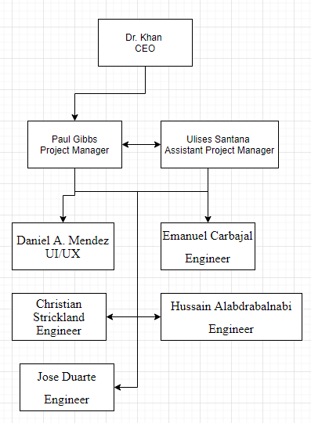

Dr. Khan (CEO) – Monitors the progress of the team as well as providing feedback during meetings. Extra communication will be given to the project managers but there will be communication with the full team.

Paul Gibbs (Project Manager) – Facilitates structure for the project and makes sure that standards set by the SRS and SPMP are met, guidelines are adhered to, and that overall progress is being made.

Ulises Santana (Assistant Project Manager) – Assists in project manager duties acting as another pair of eyes to help keep the project moving forward.

Daniel Mendez (UI/UX) – Focus on creating an intuitive User Interface and User Experience that will act as a frontend for the project

Christian Strickland, Emanuel Carbajal, Hussain Alabdrabalnabi, Jose Duarte (Engineer) – Will create and test the prototypes which will be the backbone for the project

**4.2 Organizational Tools**

The project will be divided into small accomplishable goals and recorded using Trello. These tasks will be split into a backlog, active projects, and finished tasks

1. **Managerial Process Plans**
   1. Start-up Plan
      1. Estimation Plan

* Discuss how synchronous social media could be improved
* Examine and research current social media platforms
* Decide what would need to be changed to make quick form public messaging social media into a time limited system
* Create guideline for a working prototype
* Create estimated deadlines and expectations for each sprint
  + 1. Staffing Plan

Project staff was chosen based on their individual interest in creating a social media platform that addresses the issues that felt needed to be changed in order to create a better public messaging board.

* + 1. Resource acquisition Plan

All software to be used during this project is to be free and open source used with the proper licenses. If the project is to be hosted it will be done with the free tier of Google Cloud Platform or Amazon Web Services. Individuals are to provide their own workstations as school resources are inaccessible due to Covid-19 campus lockdown.

* + 1. Project Staff Training Plan  
       All members will have attended courses to learn the basics of software engineering and the production cycle. Each member of the team is to be delegated a role and from there they are to look into the required technologies for completing their assign role.
  1. Work Plan
     1. Work activities  
        Work Units:
        1. Prototype 1: Creation of the first prototype including majority of the backend for the platform. Major parts will be central thread, users class, and method of connecting users
        2. UI/UX Adaptation: Develop a user interface that will work both across computer access and mobile.
        3. Polish, Deployment, and Bug fixes: Refine UI/UX/Dataflow based on feedback, prepare a potential public deployment, and deal with any day 0 bugs that arise.
     2. Schedule Allocation

|  |  |  |
| --- | --- | --- |
| * + 1. 9/29/20 | * + 1. 10/15/20 | * + 1. Sprint 1: Prototype 1 |
| * + 1. 10/20/20 | * + 1. 11/12/20 | * + 1. Sprint 2: UX/UI and Prototype presentation 11/17 |
| * + 1. 11/17/20 | * + 1. 12/10/20 | * + 1. Sprint 3: Deployment and Polish |

* + 1. Resource Allocation  
       All members are provided equal access to tools and documentation. Code is to be created using visual studio and open source libraries for any web connectivity and UI/UX. Workstations are self-provided or by CSUSB computer lending program.
    2. Budget Allocation  
       No budget is allocated to this project. Any hosting fees will be <$1.00 and taken care of by the Project Manager.
  1. Control Plan
     1. Requirements Control Plan  
        Each member is required to attend class and group session time that is provided during the semester. All code is to be documented through the use of Github for version control. SRS and SPMP are to be followed and any changes should be brought up with the PM and assistant PM.
     2. Schedule Control Plan  
        Group members are expected to meet deadlines and take appropriate measures to work on the project outside of the provided class time. Managers are responsible for assisting where they can during production and facilitating any extra online meetings that are to take place. Communications will be centralized through the dedicated Slack channel
     3. Budget Control Plan  
        The only costs being hosting during the deployment phase and the PM will manage that directly so that costs are kept within the $1 budget.
     4. Quality Control Plan  
        Code is to be commented appropriately so that others may understand the project without any extra explanation. Code repository is to be updated in a way that conflicts are kept to a minimum. It is the PM and APM’s task to be sure these standards are enforced.
     5. Reporting Plan  
        Progress will be reported to our stakeholder Dr. Khan during our biweekly meeting. Engineering and Design team are to report progress to the PM and APM during meetings as well.
     6. Metrics Collection Plan  
        On a weekly basis each member will report their metrics to the PM and APM to be sure that the project is on schedule. If goals are not being met then changes and help will be given as needed.
  2. Risk Management Plan
     1. Development
        1. Given the uncertain times of Covid19 teams have been formed with redundancy in mind. If a single member is unable to contribute then the work will be covered by their teammates
        2. Current weak point is there is only one member experienced with UI/UX development but others are willing to learn if necessary.
        3. Any potential difficulties are to be brought up with the team so changes can be made if necessary to the SRS and/or SPMP
     2. Project Failure
        1. If the project does not meet the standards laid out then deployment will be kept private with all code kept private
     3. Server Failure
        1. This will only be a concern during deployment but with hosting being held on the cloud through either AWS or GCP (to be determined) failure is not to be expected.
  3. Close-out Plan  
     Project is to be submitted as a Github repository with any documentation that was created for it along with a potential roadmap for further development and maintenance. An online presentation will take place during day of Finals week.

1. **Technical Process Plans**
   1. Agile Software Development

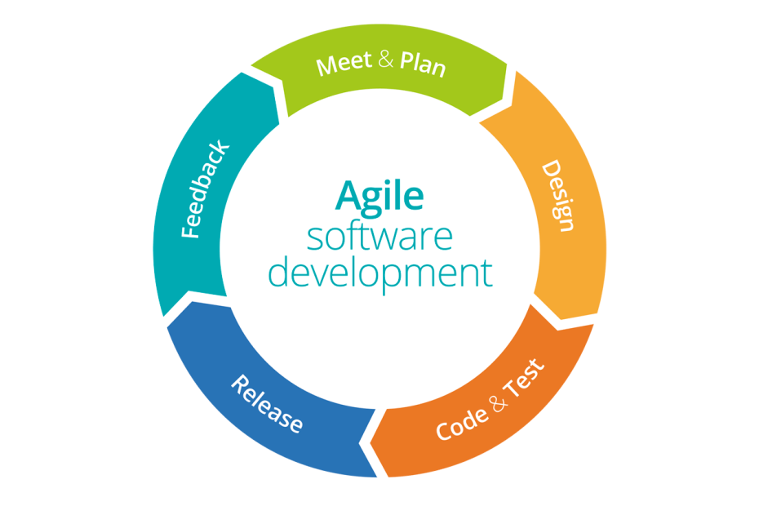

* 1. Methods, Tools and Techniques
     1. Method: Incremental Development Model
     2. Tools: Visual Studio, Slack, Trello, AWS/GCP and Microsoft Word
     3. Techniques: Agile workflow utilizing work from home adaptations.
  2. Infrastructure Plan  
     Until the deployment phase there is no infrastructure, once there AWS or GCP will be used to host the project using their respective infrastructure tools
  3. Product Acceptance Plan   
     When milestones are met at the end of each sprint we will request feedback from the CEO who is the main stakeholder for this project. Feedback will be turned in to changes and applied to the project.

1. **Supporting Process Plans**
   1. **Configuration Management Plan**
   * As our project is starting locally and we will be using GitHub as our way to configure software.
   1. **Verification and validation plan**
   * Verification and validation are done through periodic testing of the Web App. Any bugs or errors that are found are documented and reported through Trello. This process of validation will be revisited to assure quality.
   1. **Documentation Plan**
   * The managing team will prepare and plan the SRS and SPMP. The development team will write the documentation for design and architecture.
   1. **Quality Assurance Plan**
   * Bugs and errors at the end of testing will contribute to providing better quality but because we don’t have a specific QA team, we will implement quality assurance after the second sprint.
   1. **Reviews and audits**
   * We will have audits of certain features and functions done by someone who is not the one who developed it to ensure more than one perspective. Since we will keep track of bugs and errors, we will be able to add their fixes in the sprint backlog.
   1. **Problem resolution plan**
   * Each member of the development team will keep the managing team members up to date on any issues that they might encounter. Afterwards the managing team will decide on how to handle those issues and make sure that the project is completed. They will also make any changes necessary to make sure that the project runs as smoothly and as efficiently as possible.
   1. **Subcontractor management plan**
   * We have no subcontractors.
   1. **Process improvement plan**
   * In order to improve the process and development of the software, it is crucial to write a good Documentation of the source code that they will be provided. There are features that cannot be implemented in the given time at the moment, and therefore have been pushed back to the next stage of development. Writing quality code now, documenting it and creating a good maintenance manual will help the future development team to make all the changes that they think are necessary. We also made sure that the client was kept up to date on these features, and so he will also be able to help the future development team figure out what to do next.
2. **Additional Plans**

Possible future success may have our team expand on additional plans of progress.